Brian Robson Memorial Lecture
High Hopes, Hard Realities: Civic Universities at the crossroads
University of Manchester
John Goddard
Emeritus Professor of Regional Development Studies
Newcastle University
November 2025

Summary
Manchester alongside Newcastle, Sheffield, Leeds and Birmingham is one of the initial group of civic universities that evolved in the great Northern cities of the UK. Brian Robson linked two of these cities. He grew up and went to school in Newcastle and based his PhD on the growth of that City. He then not only went on to an illustrious academic career in Manchester University but also to lead the University’s re-engagement with its city and region
In this lecture I will update the case made in my 2009 NESTA Provocation to Reinvent the Civic University to the very different economic and political environment in which archetypal UK civic universities in core cities outside London are now operating. I will draw on the report of the Civic University Commission Truly Civic: Strengthening the connection between universities and their places and the follow-on Civic University Network.
I will suggest how the ties (and accountability) of this group of universities to their communities have been diluted because of the funding regimes and related competitive pressures driving up the need to raise national and international profiles, research reputations and attractiveness to overseas students. Indeed, the imperatives highlighted by the Civic University Commission have been working against the grain in these institutions, and as a result they have some way to go to meet their full potential as ‘truly civic’
But I conclude by recognising the policy landscape is changing with the UK Secretary of State for Education proposing (in a letter to Vice-Chancellors) that universities “Play a greater civic role in their communities”. This is a welcome formal acknowledgement by the Government of the importance of universities’ civic role and suggests that it could lead to a greater incentivisation of this in future. This is also a future in which city region Mayoral combined authorities - in the context of the forthcoming English devolution bill - could be pivotal. I suggest this will require bottom up as well as top-down change. For universities, a collaborative mindset at odds with prevailing attitudes and practices. For policy makers across Whitehall silos a clearer incentive structure to collectively support universities’ civic mission.
Going forward, I anticipate that the coincidence of multiple crises across the world and populism -which has its roots in left behind places - will have far reaching implications that universities cannot ignore. Indeed, I will argue that if they do not step up to the plate and assert their civic role as anchor institutions in their places, the very existence of some universities may be at stake.

Introduction
As a great admirer of Brian Robson, I am honoured to be asked to give this lecture.
Special thanks to Cecila Wong for nominating me. Cecila was a researcher in the Centre for Urban and Regional Development Studies (CURDS) in Newcastle, which I founded in 1977 and led for twenty years. CURDS won successive rounds of core funding from ESRC and was reviewed by, guess who – Brian Robson!
In working on my autobiography, I have realized that Brian’s career trajectory - as an urban geographer, working with the Economic and Social Research Council and subsequently applying his experience in a leadership role in a university, had similarities to my own.
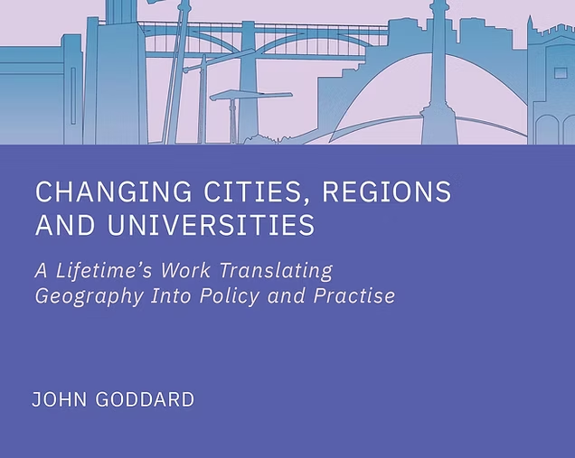

Following short periods as head of Geography and Dean of the Faculty of Arts and Social Sciences in Newcastle, I was asked by a new VC in 2001 to become his deputy and translate the work of CURDS into practise and join with him in a process of re-engagement of the university in the city and region.
Brian took up his post in Manchester in 1977, established the Centre for Urban Policy Studies in 1983, was head of geography, faculty dean and PVC for external engagement between 1993 and 1997. Uncanny parallels
Our contributions were recognised by gongs from the Royal Geographical Society and the Queen.
Maybe a long period of service in one institution in a core city outside of London was important.
Indeed, as my mentor, the renowned Swedish social geographer of time , Torsten Hagerstrand told me that a move to Newcastle from LSE would be a good one if I wanted to make a difference to society. He told me that in London there was an excess of worthwhile combinations. ’ How right he was.
Like Brian, higher education was not my academic background. We both learned about HE on the job as we endeavoured to bridge two very different academic and policy traditions – indeed silos. One where the object of study and target of policy was places and the other the university as an institution - In places but not of them. It was a world i which universities were unfathomable black boxes to local authorities and university leaders had no understanding or interest in how the city functioned.
Some History and Geography
It was not always like this. Going back to the 19th Century, we saw the emergence of locally endowed proto universities in growing cities like Newcastle, Sheffield, Manchester and Birmingham. They used applied science to support mining and manufacturing; medical science to help create a heathy workforce; and sought to stimulate civic life through public discourse on the future of science and of society at large.
In the 20th century, these so-called ‘redbrick universities’ became less engaged with their places as central government become more directly involved, providing funding via the University Grants Committee. The government-driven expansion of the university system in the 1960s through the founding of new universities outside of big cities, just as these were facing major problems
Expansion in the 1970s - to meet a government 50% target for the participation of young people in higher education - was unplanned in geographical terms. Throughout this period, the governance of the UK became increasingly centralised, and the powers and resources of local government were slowly reduced.
The lecture
In Newcastle we had challenged this and the then CEO of the NESTA foundation, Geoff Mulgan, invited me on my retirement in 2008 to become a NESTA Fellow and write a Provocation Reinventing the Civic University . Tonight, I want to roll forward the ideas that publication to the different economic and political environment in which archetypal UK civic universities in core cities outside London are now operating. In this I will draw on the 2018 report of the Civic University Commission Truly Civic: Strengthening the connection between universities and their places and the follow-on Civic University Network.
In doing this I must acknowledge the role of the late great Lord(Bob) Kerslake who joined up the worlds of local government and higher education in successive roles as Chief Executive of Sheffield City Council, permanent secretary of what is now the Department of Communities, Housing and Local Government , head of the home civil service and chair of Governors of Sheffield Hallam University. He did this before taking on the role of Chair of the Civic University Commission where he invited me to be his deputy. ( It’s worth noting that this was not a Government Commission but sponsored by a charitable foundation linked to a business providing student housing )
I will go on to suggest how the ties (and accountability) of the great civic universities to their communities have been diluted because of the funding regimes and related competitive pressures driving up the need to raise national and international profiles, research reputations and attractiveness to overseas students.
Indeed, the imperatives of civic engagement highlighted by the Civic University Commission have had to work against the market pressures driving all universities, and making the journey to being ‘truly civic’ very challenging
But I conclude by recognising the policy landscape is changing with the UK Secretary of State for Education proposing (in a letter to Vice-Chancellors) that universities “Play a greater civic role in their communities”. This is a welcome formal acknowledgement by the Government of the importance of universities’ civic role and suggests that it could lead to a greater incentivisation of this in future.
This is also a future in which city region Mayoral combined authorities - in the context of the forthcoming English devolution bill - could be pivotal. I will suggest that this will require bottom up as well as top-down change. For universities, a collaborative mindset at odds with prevailing attitudes and practices. For policy makers across Whitehall silos a clearer incentive structure to collectively support universities’ civic mission.
Going forward, I anticipate that the coincidence of multiple crises across the world and populism -which has its roots in left behind places - will have far reaching implications that universities cannot ignore. Indeed, I will argue that if they do not step up to the plate and assert their civic role as anchor institutions in their places, the very existence of some universities may be at stake.
Knowledge domains
Let me now go back to my opening remarks about the different knowledge domains that Brian and I both inhabited. There are two distinct fields, and I have learned to bridge them by iterating between thought, policy and practise
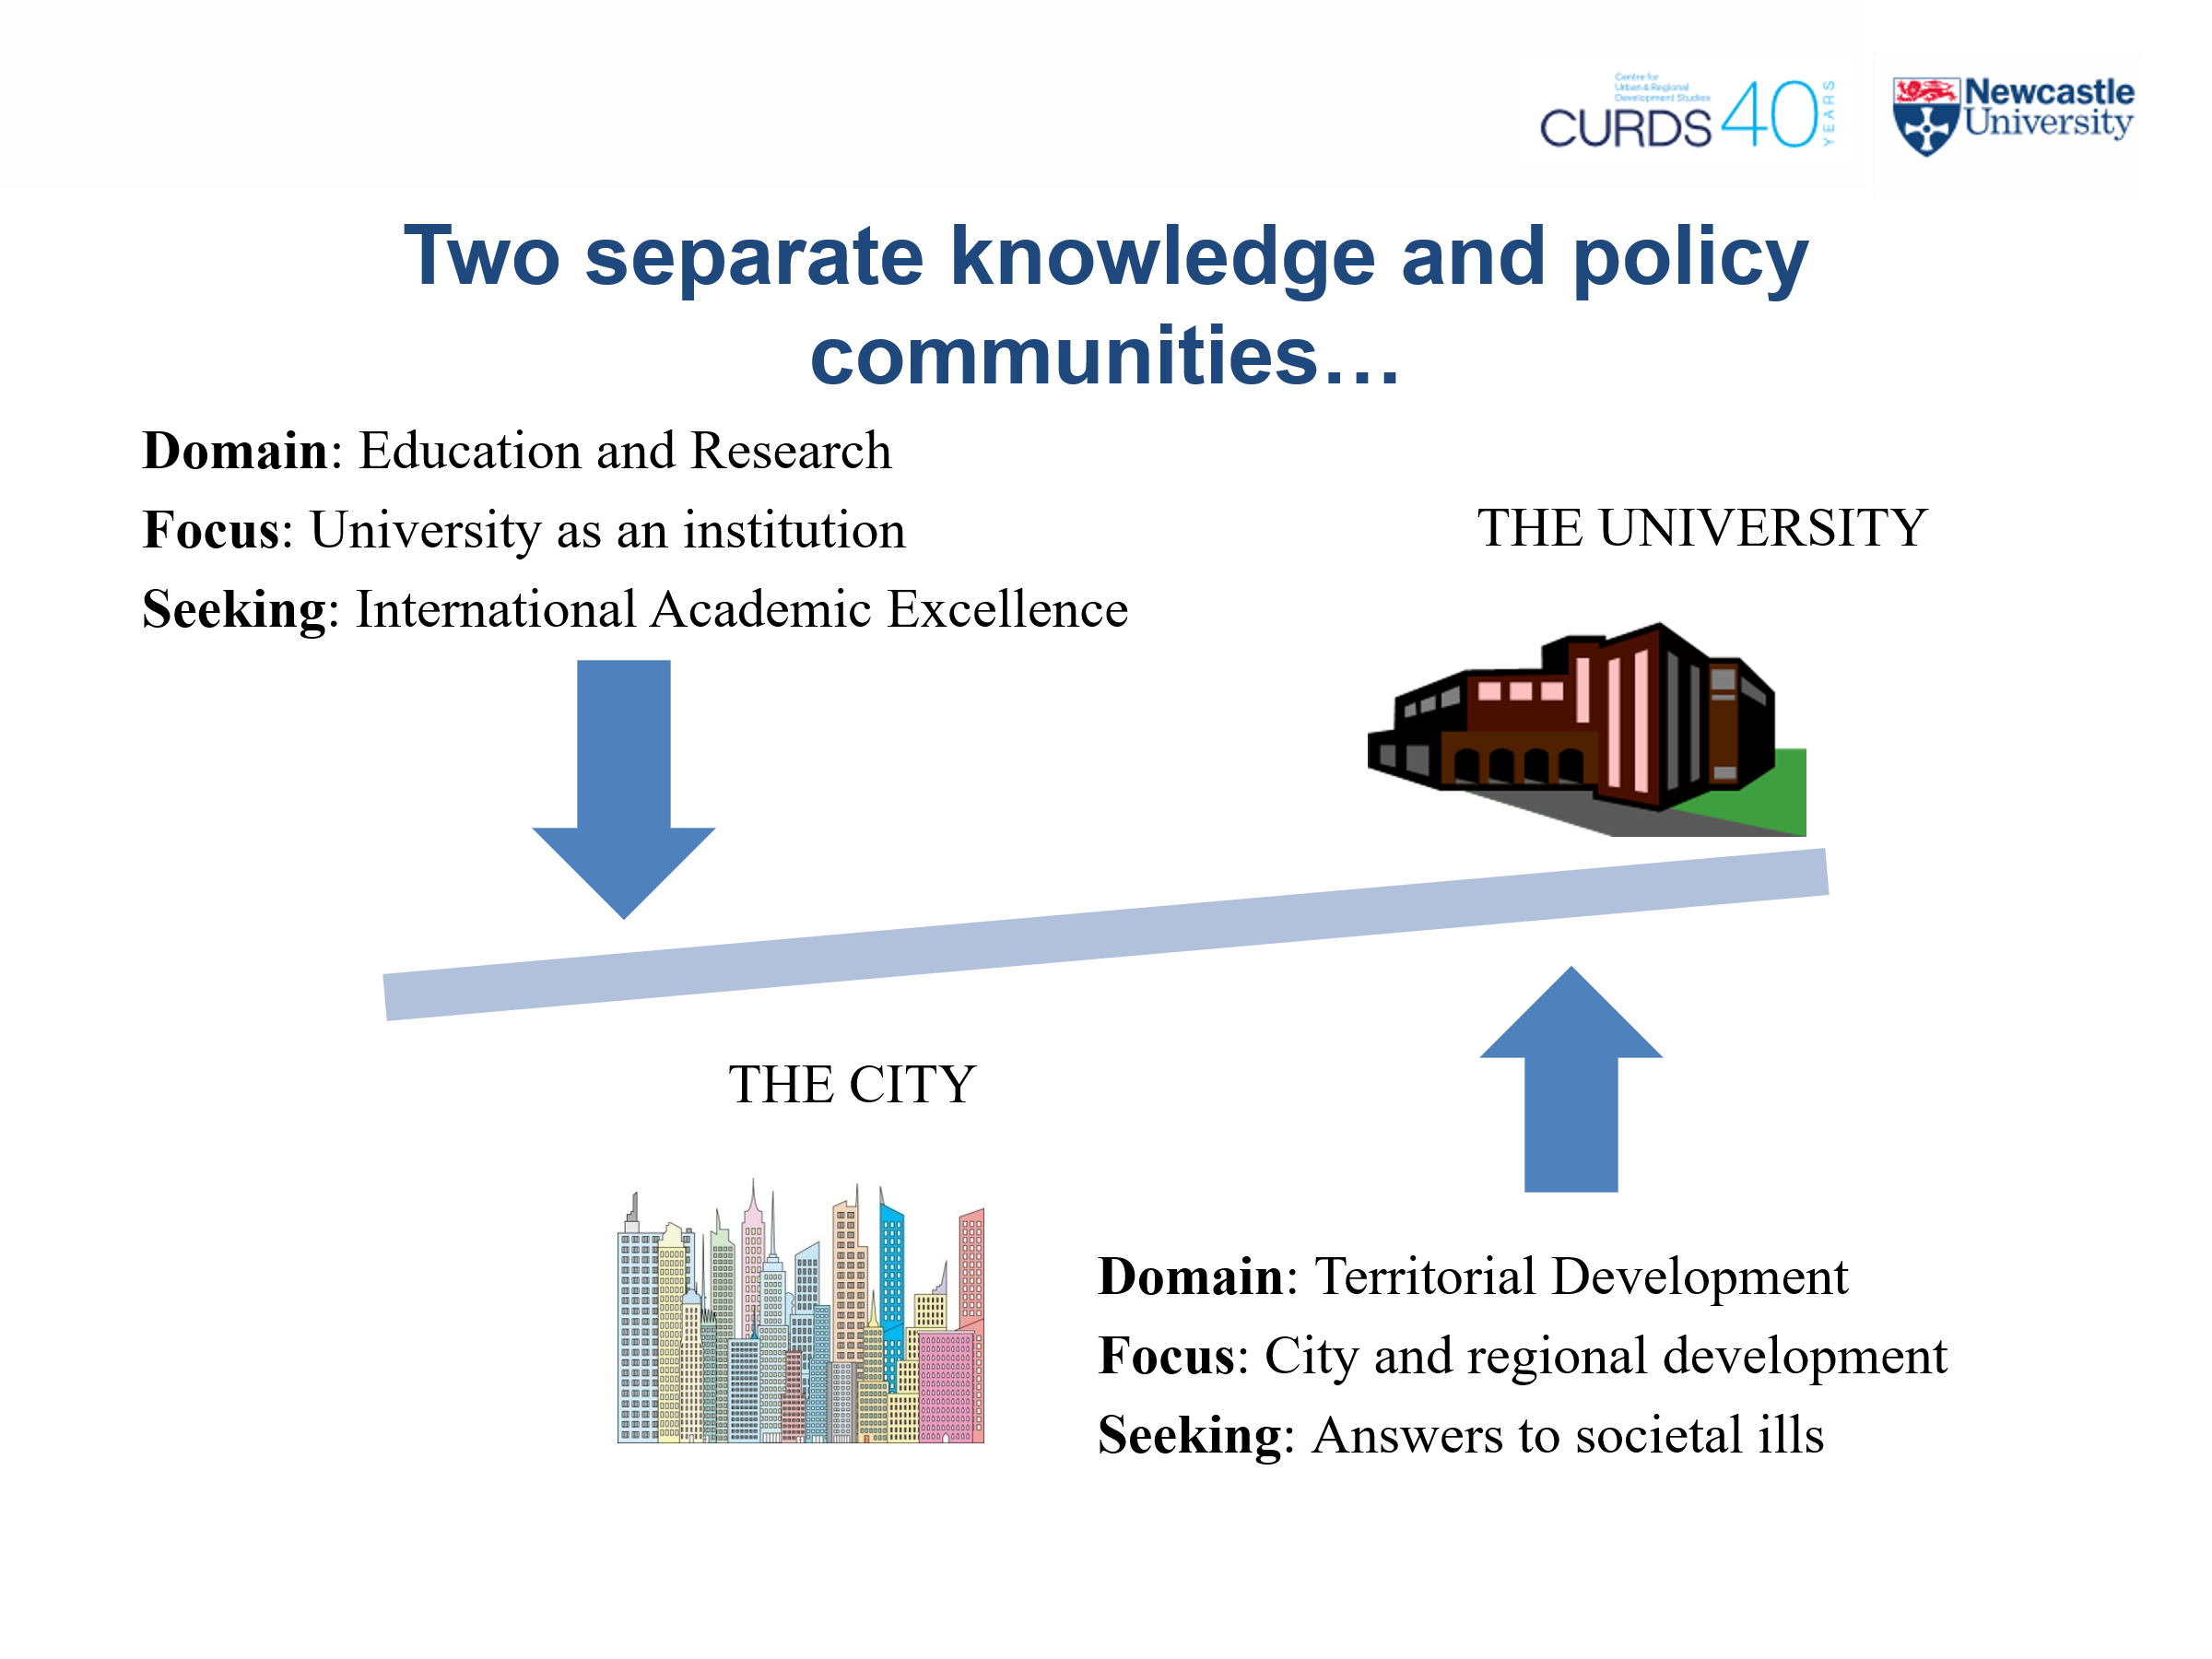
After I retired and with the support of a Leverhulme Foundation grant, I reflected on the role of universities in successive publications, the first adopting an outside in and the second an inside out perspectives
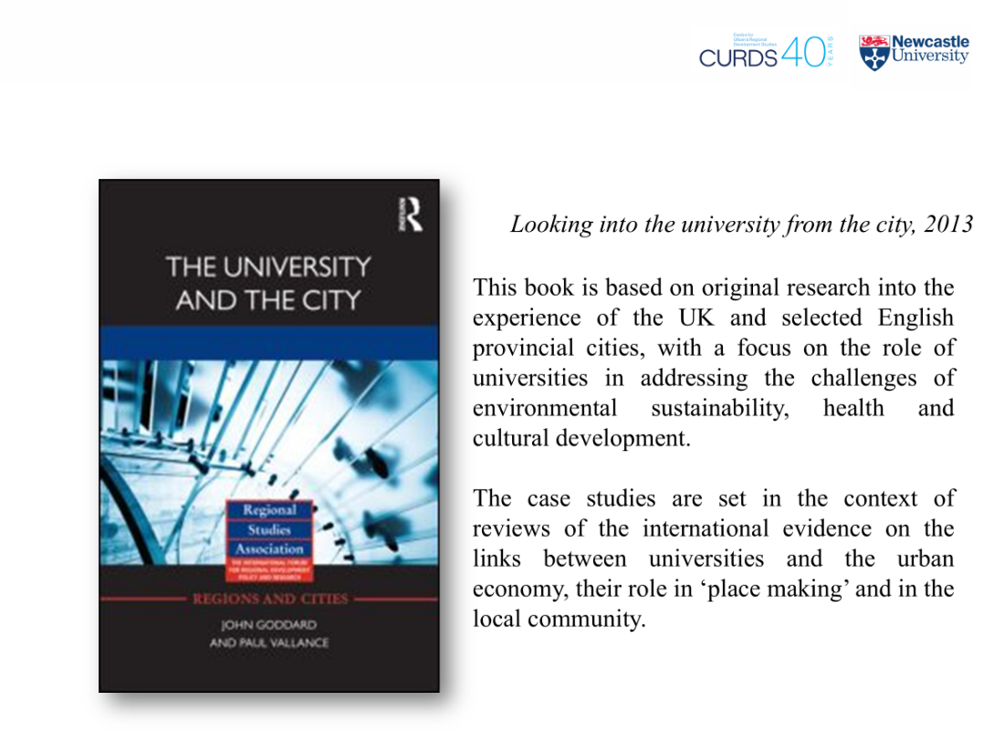

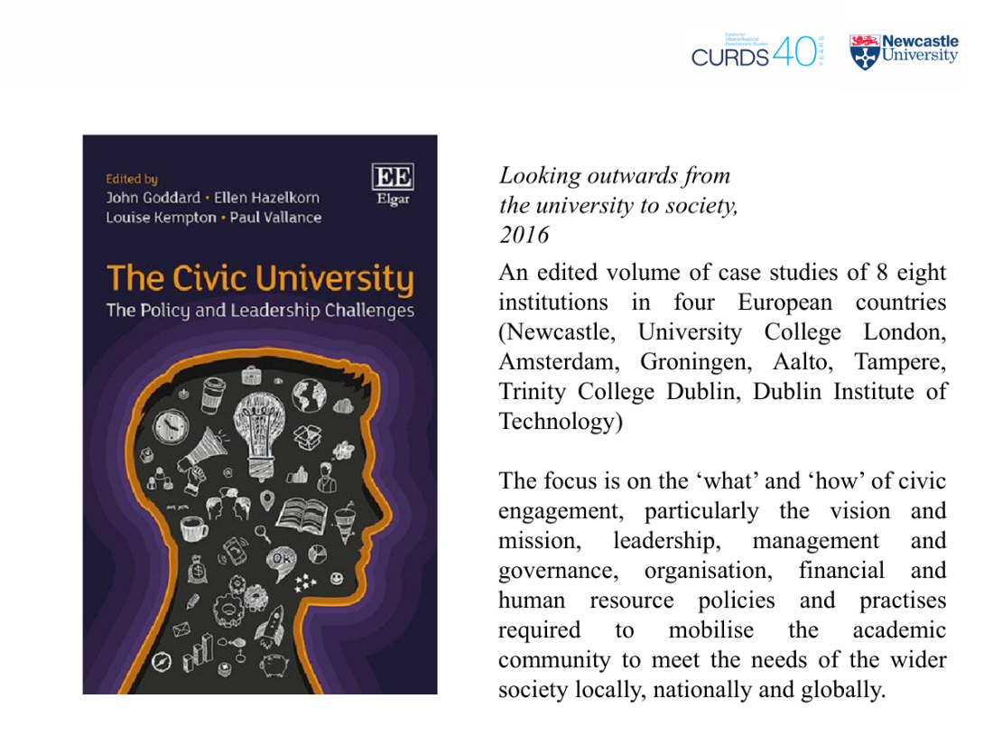

Two key related points emerge from these different perspectives, one that is on uncontroversial and the other normative and aspirational
First, across the globe places – towns and cities where people live and work - have been, are and will be in the future on the frontline of global economic, political, social and environmental change.
Second, universities should have a key role to play in meeting the challenge of multiple global crises through their teaching and research and acting as ‘anchor institutions’ tying down the global in the local.
This means that they need to help and be seen to be helping their places actively navigate an increasingly turbulent world – part of the solution and not part of the problem of global institutions that have been among many actors and agents contributing to economic, societal, political and environmental breakdown
I believe universities as institutions must intentionally and actively work with their local communities to plan a way ahead for both
In this I must emphasise past, present and future. Actors and agents in this space need to understand the evolution of universities and their places – history and geography matter. We must share the accumulated wisdom of the academy to avoid the continual re-invention of the wheel by new generations of policy wonks. Google searches are not enough
And that is where the combination of the leadership of institutions AND of places – territorial governance – to use the jargon - is critically important. Or more colloquially, how VCs and Mayors as well as academics, administrators, business leaders and above all citizens have to work together to prevent community breakdown
Going forward, the key challenge is the coincidence of so many dimensions of change in time and space. Most notably, it is the unwinding of the post second world war global order. Universities have helped shape this order through the creation and spread of knowledge and student mobility. Indeed, throughout the ages, universities have played a key role globalisation.
If there is one driver that connects the various crises it is a backlash against free markets and globalisation. This has multiple epicentres in left behind places. And it is where universities can be seen as being driven solely by the academic market. Or put another way as globally connected but locally disengaged.
We all know universities are not place bound – the very essence of a university is that it is involved in the creation of knowledge chiefly through research and the universal sharing of knowledge particularly through teaching and where reach is not necessarily limited by time and space . Also, that citizenship is not necessarily only about place – we are all citizens of the world.
But this does raise the question of how we in the academy are accountable for our actions as citizens
Universities as Anchor Institutions in Places
A now conventional response highlights their role as ‘anchor institutions’. These were originally defined by Will Hutton for the Work Foundation as:
Large locally embedded institutions, typically non-governmental public sector, cultural or other civic institutions that are of significant importance to the economy and the wider community life of the cities in which they are based.
They generate positive externalities and relationships that can support or ‘anchor’ global economic activity in the locality
‘Anchor institutions do not have a democratic mandate, and their primary missions do not involve regeneration or local economic development. Nonetheless their scale, local rootedness and community links are such that they can play a key role in local development and economic growth representing the ‘sticky capital’ around which economic growth strategies can be built’
What does this term ‘anchoring’ mean for universities?
- Relationships with other institutions that inhabit the place
- Normative questions about the need for academic practise (research & teaching) to be of relevance to the place in which practitioners live and work as citizens
- Exploration of a more broadly conceived territorial development process than just economic growth and competitiveness
- Interrelated physical, social and cultural dimensions

The Civic University
This leads me ask what this implies for the leadership and management of universities. The traditional university has separate pillars for teaching and research as primary missions and may have a ‘third mission’ around civic engagement which is inferior. There can be a hard boundary between the core activities of teaching and research and isolated short-term projects with the outside world where the focus is on income generation. Unfortunately, short term funding works against building trust based relationship with civil society.
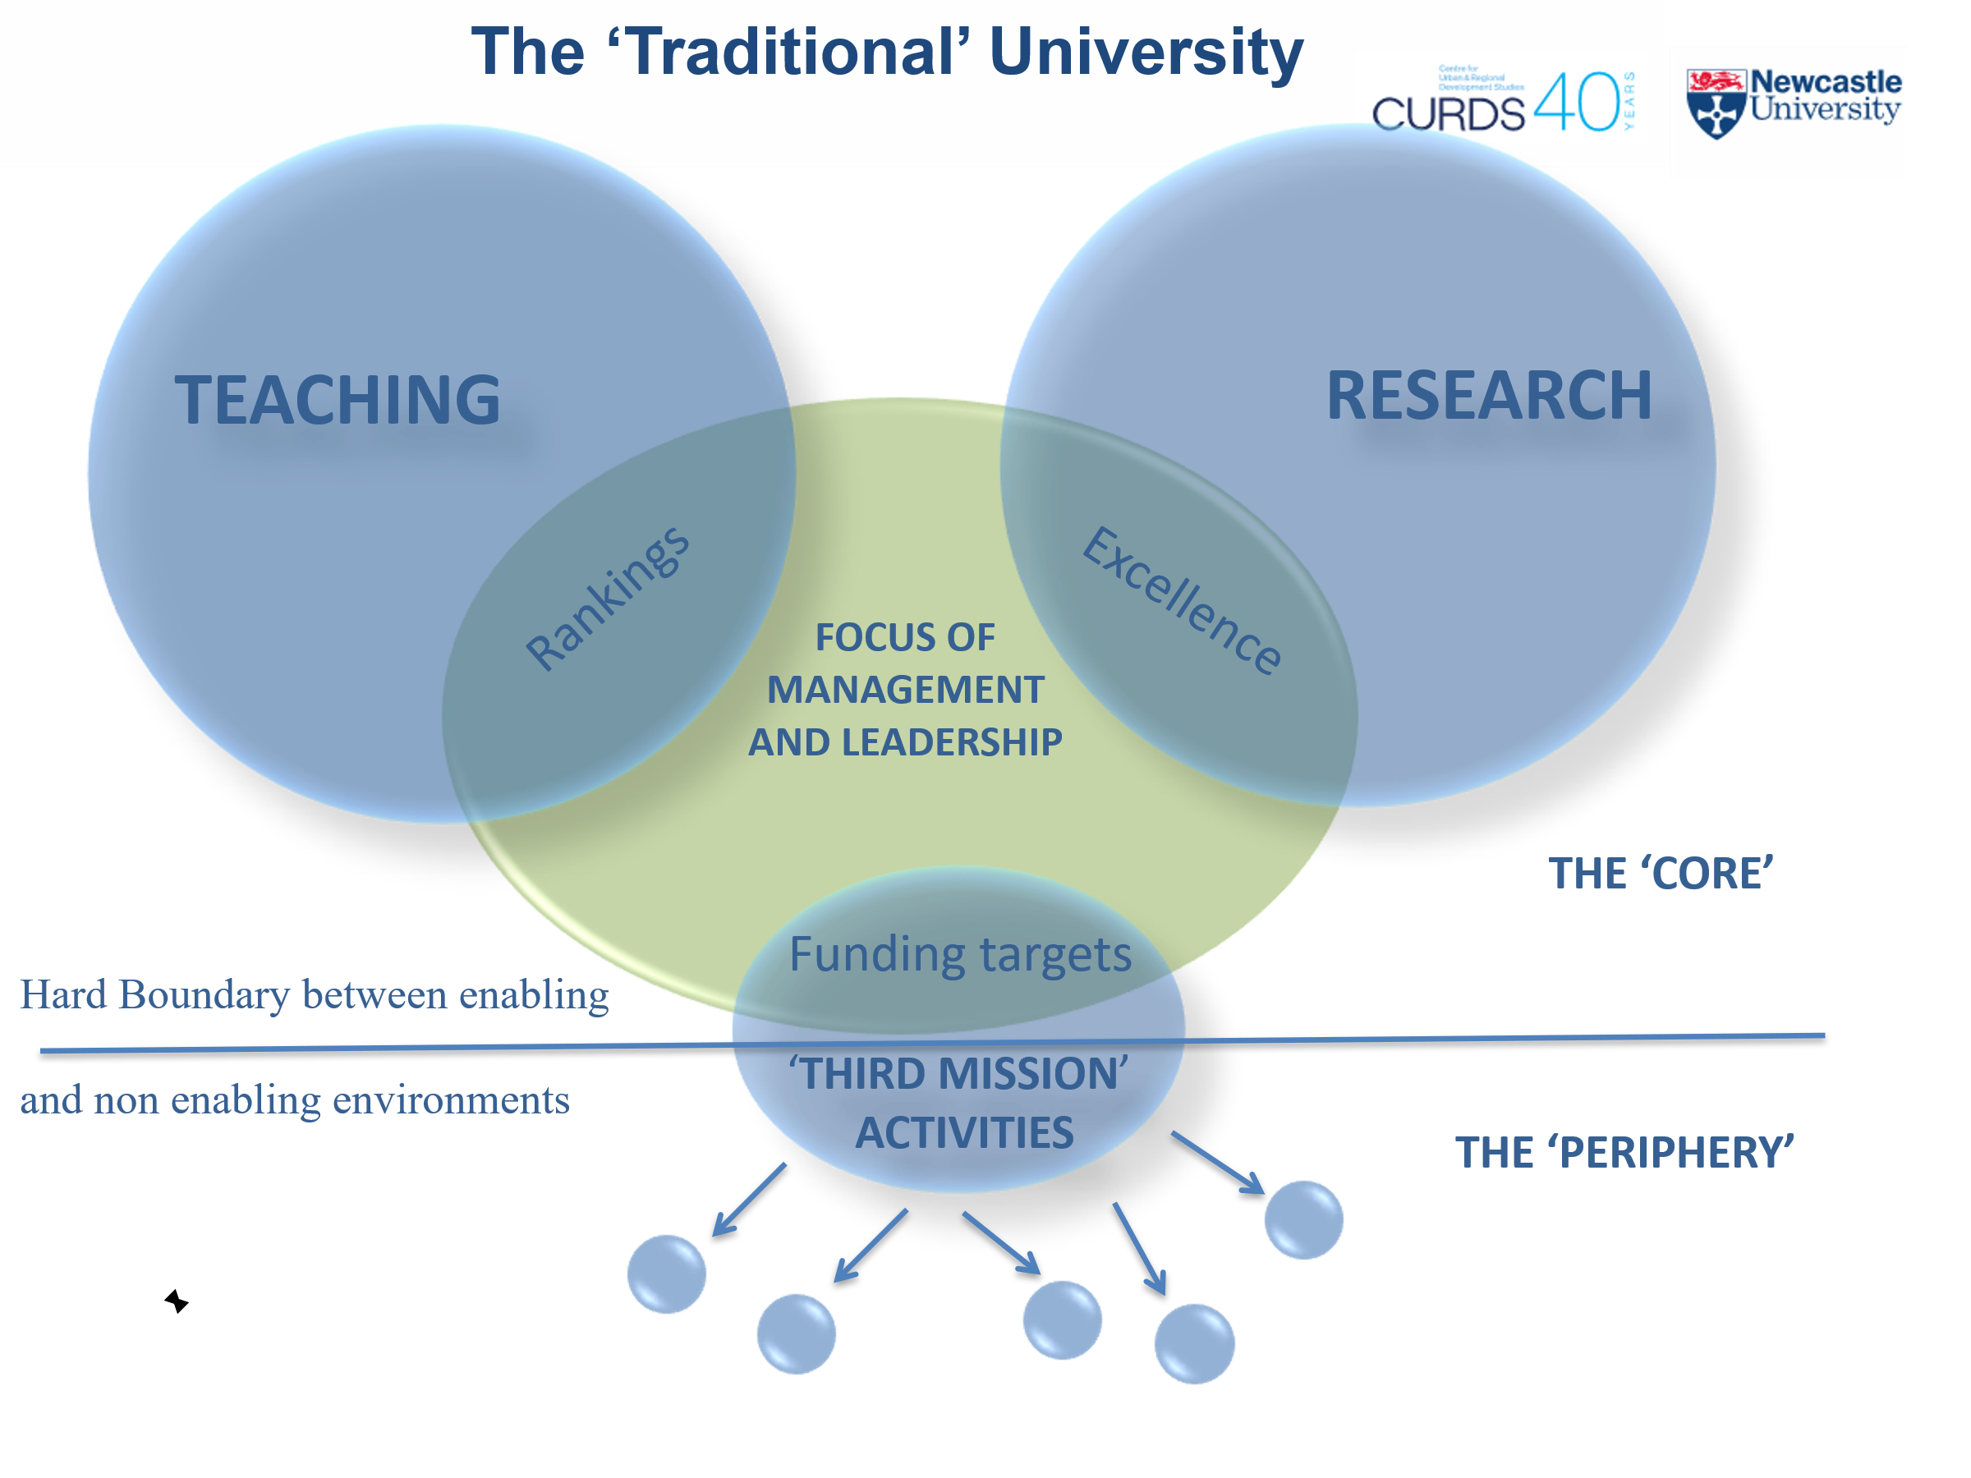

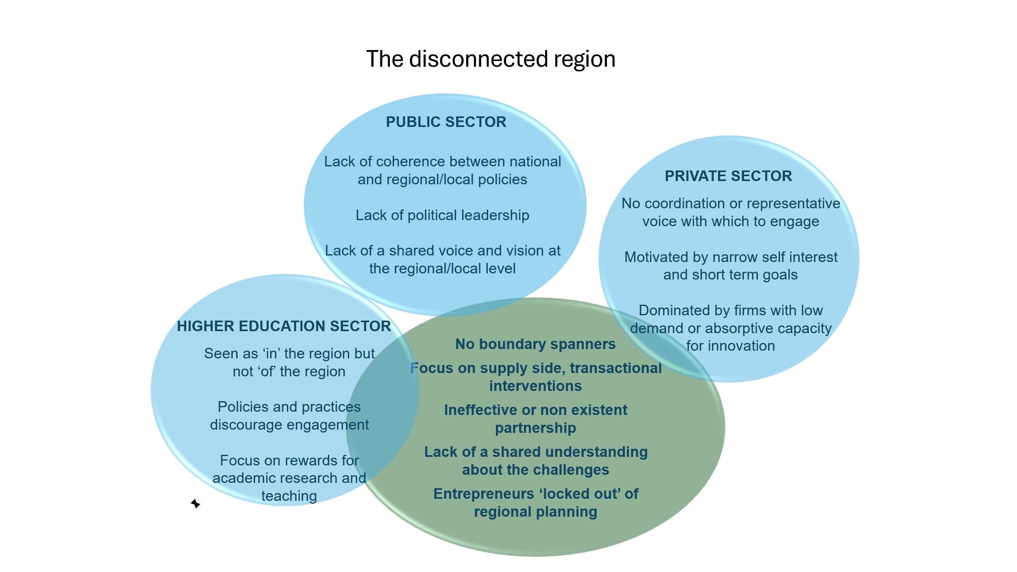

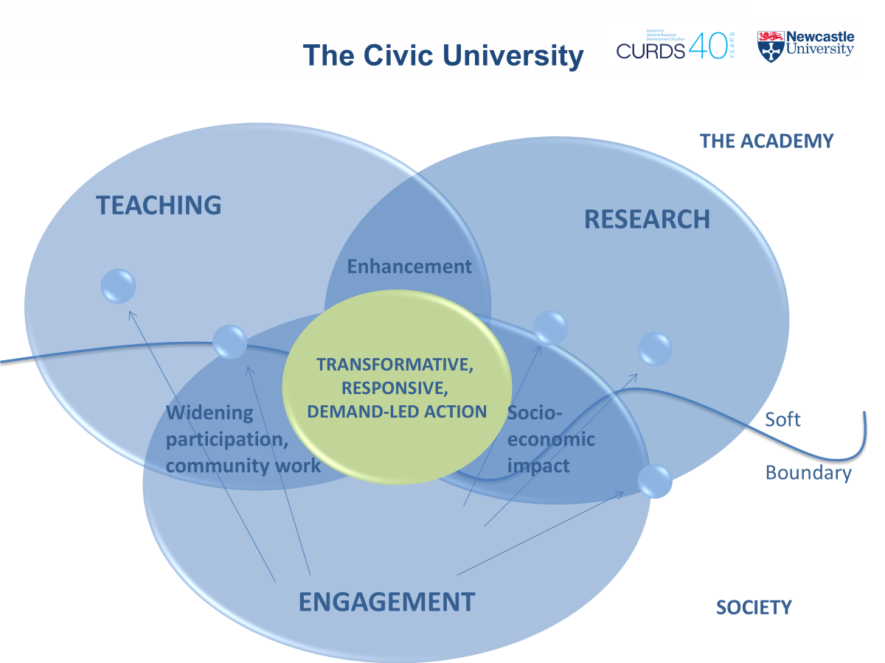

In the civic university engagement with society is embedded conjointly in teaching and research. Transactional project-based knowledge supply relationships are replaced by long term transformational societal demand or needs based relationships for example those set out in the SDGs. But to build capacity for these relationship – inside out and outside in – the university still needs earmarked resources to facilitate delivery. This may be in the form of physical infrastructure where conjoint activities can take place and personal development programmes are available to help individuals work across boundaries.
This is clearly a normative model which imposes conflicting demands on university leaders. Their institutions have to be not only excellent in terms of conventional academic criteria but also seeking to contribute to the public good. While responsibility to society is not new, it has been given greater saliency as the challenges facing society heighten in intensity. This responsibility has to be balanced against the challenge of participating in a global higher education marketplace with its own internal logic in terms of competition for mobile students and academic staff.
To do this requires managing the tensions between the demands from within and without higher education, including embedding external engagement into the internal process of managing the teaching and research undertaken by academic staff. It also requires managing conflicting signals in the external policy environment, not least in terms of the degree of focus of national governments on the global higher education and research marketplace relative to contributions to society in general and their local community in particular
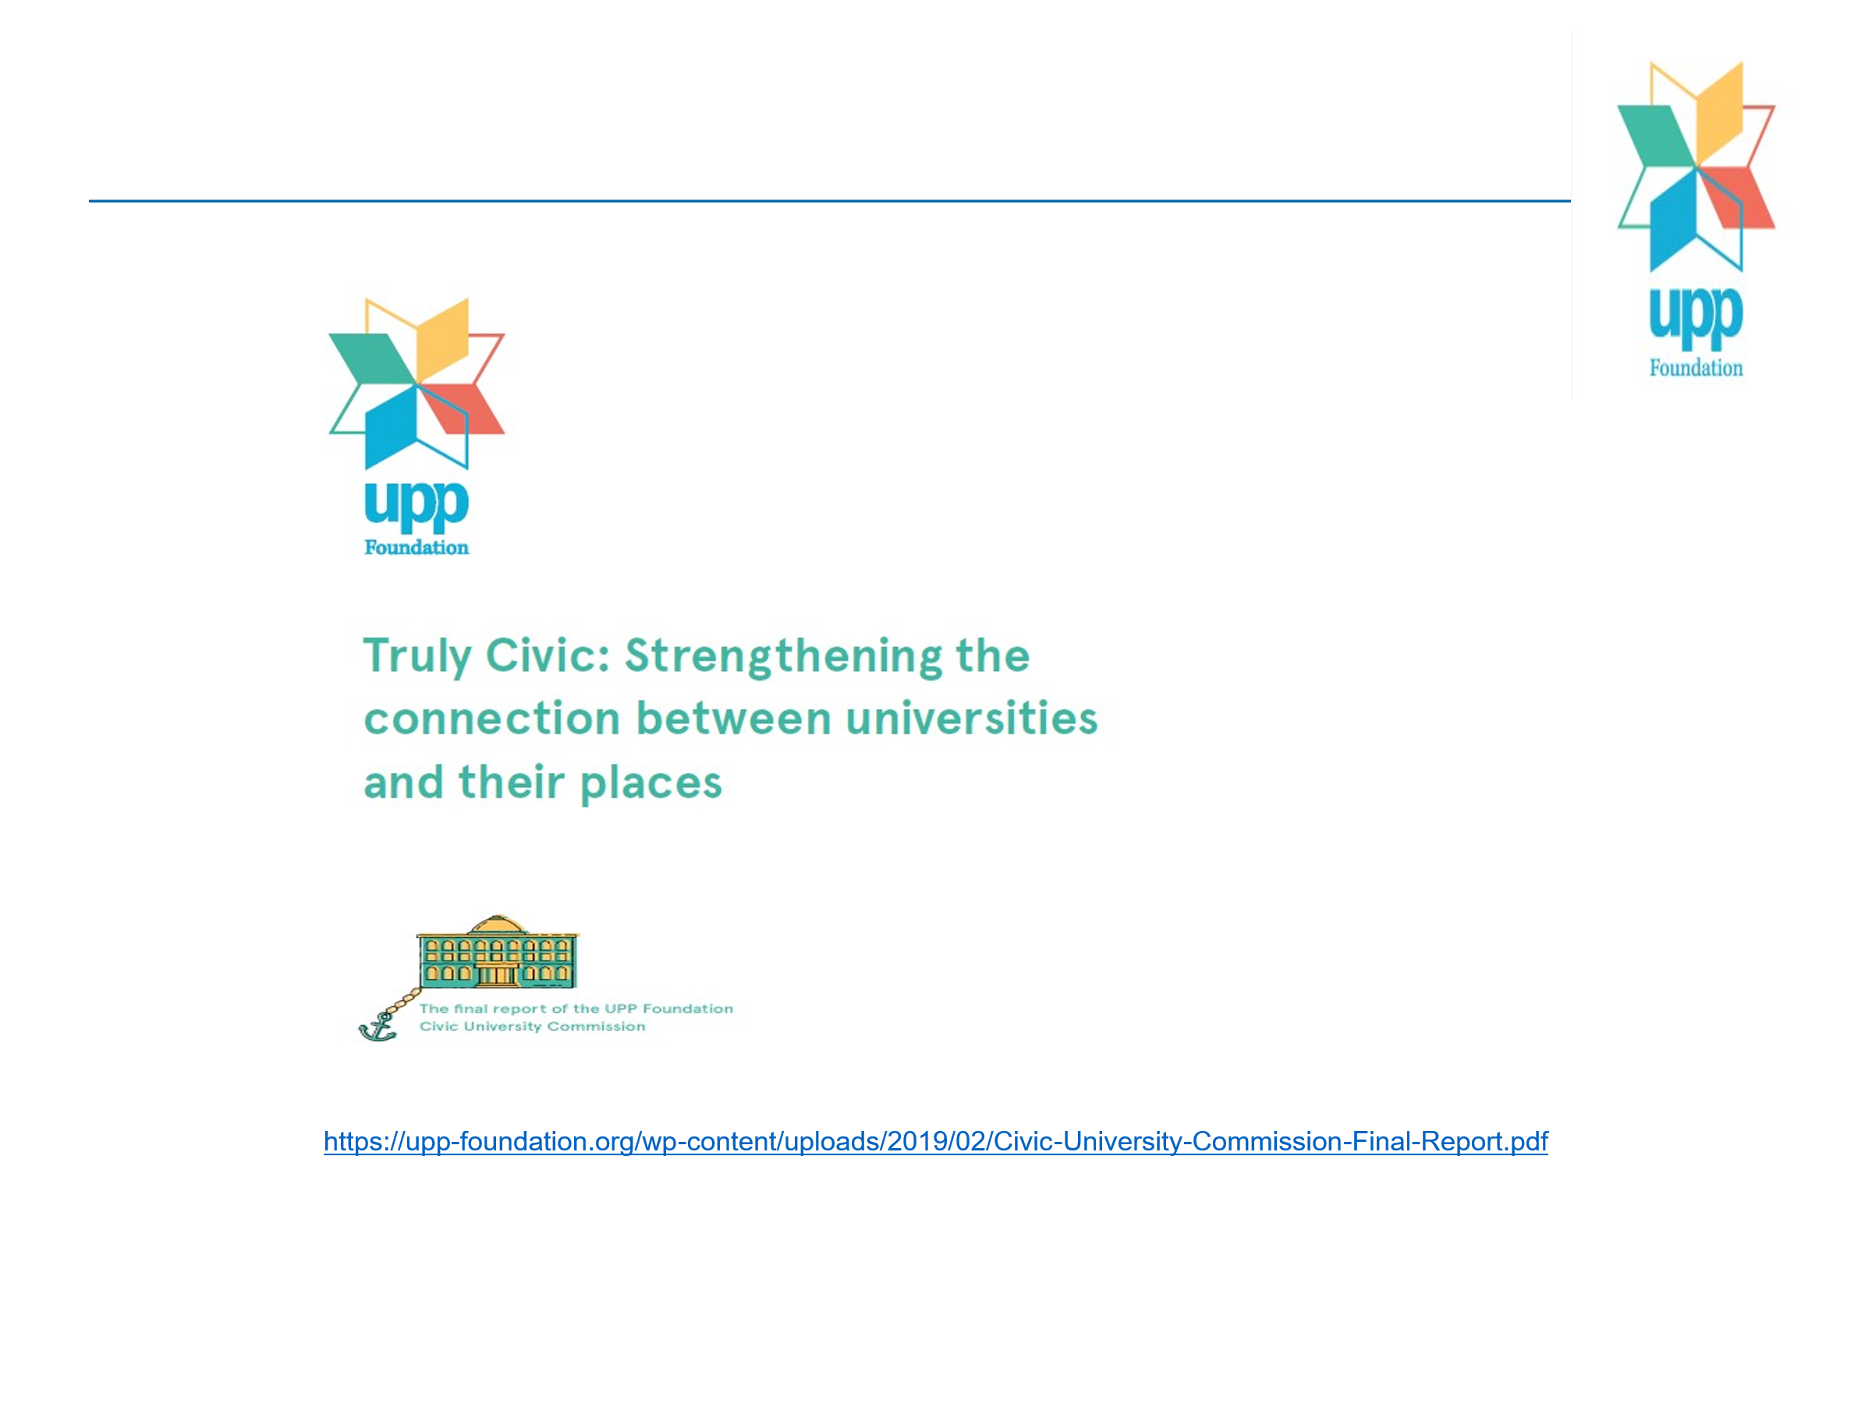
The UK Civic University Commission
The Civic University Commission investigated how far universities were living up to these societal expectations. We found a lack of local accountability There was Ignorance of local people about the contributions universities make to their community especially amongst less advantaged. Many felt that income from fees should be used for individual student benefit and not the general public – for example sports facilities.
There was a lot of engagement activity, but a lack of strategic intent based on analysing and meeting needs of people who grow up, live and work locally, including for lifelong learning.
Short-term project funding mitigated against long term trust based collaborative partnerships including schools and the community and voluntary sectors.
Whilst some university leaders professed their institution’s civic role and some academics were active in the community, resource controllers in academic departments and faculties focused on narrow REF outputs and student satisfaction scores .
Finally, individual central government departments were independently funding university work, each with different expected outputs , for example business startups, graduate incomes and public health. There was no cross-government view as to the role of universities and the future development of places in the round
The Commission recommended that universities that aspired to be civic institutions should prepare Civic University Agreements co-created and signed with other key partners. This would involve
- Understanding local populations and asking them what they want. Understanding themselves.
- Working with other local anchor institutions, businesses and community organisations to agree where the short medium and long-term opportunities lie in a given area.
- A clear set of priorities.
The output of all this strategic analysis, local engagement and prioritisation should be a funded action plan.
Following our report 100 university leaders publicly committed to prepare Civic University Agreements and accepted the following principles around place, public consultation, partnership impact measurement. More specifically
- As a place-based institution we are committed to attaching a high-priority to the economic, social, environmental, and cultural life of our local communities.
- Our civic role will be informed by an evidence-based analysis of the needs of our place, developed collaboratively with local partners and informed by the voice of our local community.
- We will collaborate with other universities and anchor institutions and form partnerships to overcome the challenges facing our local communities.
- With our partners, we will be clear about what we do and how we measure it, so we can say with confidence what we have achieved – and how we might do better in the future.
To support universities in delivering Civic University Agreements the Commission facilitated the establishment of a Civic University Network to share knowledge about how do this. The Network has subsequently been supported by a Research England contract for a Civic Impact Accelerator programme, which ends next month, and where I have been senior policy advisor.
High Hopes and Hard realities
A letter last November to all VCs from the Secretary of State for Education raised high hopes across the network. She wrote:
Universities should play a greater civic role in their communities. Our higher education providers already play a vital and varied role in their communities and regions: as employers, skills providers, research institutions, and more. I want to build on this and ensure that you play a full part in both civic engagement, ensuring local communities and businesses benefit fully from your work; and in regional development, working in partnership with local government and employers to shape and deliver the economic and social change that is needed across skills, research and innovation. This civic contribution must be locally led, and you will each have distinctive and different roles to play, but I am clear that the government will want it to form a core part of a renewed vision for the sector.
Yet the hard reality is that there is currently no statutory duty on universities to collaborate with their local communities, nor is there funding to support it. Indeed, universities currently face financial challenges through the loss of well-funded overseas students who have cross subsidised home undergraduates and loss making research. As a result, they are under pressure to look inward - to compete for dwindling resources and funding – rather than looking outward to build meaningful collaborations with their places, including neighbouring HE and FE institutions. A forthcoming tax on overseas students will add to the precarity of civic engagement.
Institutional responses
A roundtable of local and national policy makers and practitioners from inside and outside HE convened by NCIA has revealed that infrastructure to support civic engagement is unwinding. Across the country civic teams are being disbanded, leading to the dissolution of long-term place-based partnerships and communities without vital social infrastructure.
Relationships that have taken years to build unravel when civic staff depart or programmes end abruptly. Local authorities and community organisations lose their university partners along with the expertise and capacity they brought to the table.
This loss extends beyond individual positions. Participants in the roundtable emphasised that civic work does not happen by accident, it requires institutional choice, commitment, resources and long-term thinking.
All too often civic engagement relies on passionate individuals doing excellent work without adequate support, which is fundamentally unsustainable. When universities restructure under financial pressure, civic responsibilities fall between gaps without adequate academic workload allocation.
This is not surprising. The Higher Education and Research Act 2017 unleashed regulated competition and capped fees for home undergraduate and a free market for international (largely postgraduate) students. The discipline-based REF underpinned by academic peer review, is now used by the media to create global rankings of universities that disregard place.
The logic of marketisation means winners and losers. Potential university closures or defensive mergers are underway with little regard to their civic roles. 50 institutions have been identified by OfS in evidence to the Commons Select Committee on Education as at risk of exiting the sector. This is process being overseen on a case-by-case basis by the Department for Innovation, Business and Skills, supported by international management consultancies. OfS is monitoring the financial health of universities insofar as it might impact on the student experience. But there is no explicit geographical dimension to OfS responsibilities even though mergers and closures will have a dramatic impact on students.
Notwithstanding the Secretary of State earlier exhortation, the follow-on White Paper just published says very little about the future of universities let alone their civic role
It references the need for interdepartmental work on the skills agenda but the lack of reference to the Ministry of Housing, Communities and Local Government (MHCLG) is indicative of limited concern with place
As DfE has no funds to support the Secretary of Sates’s ambitions, the Department has turned to DSIT interest and resources to support university business interaction where the key framing is triple helix partnerships and putative business clusters and university specialisation.
Most notably In announcing the Global Talent Fund allocation to selected universities Science Minister Lord Vallance said:
Genius is not bound by geography. But the UK is one of the few places blessed with the infrastructure, skills base, world-class institutions and international ties needed to incubate brilliant ideas, and turn them into new medicines that save lives, new products that make our lives easier, and even entirely new jobs and industries. Bringing these innovations to life, here in Britain, will be critical to delivering this government’s Plan for Change.
There is no reference here to citizen participation in quadruple helix partnerships, notwithstanding the fact that in the digital economy, especially ubiquitous professional and public services, the link between research and innovation can no longer be seen as a linear process.
In the words of a very incisive EC report:
Innovation happens in complex ecosystems. Too often, we imagine innovation in a linear way, as a pipeline with inputs and outputs. But where we focus only on the pipeline, we miss the real needs of Europe’s more diverse and demand-driven innovators. We need more open collaboration, both globally and locally between citizens, governments and inventors at home”
“Focus on People, Places and Processes. Europe needs better assets as well as a broader vision. We have to get back to basics: upskilling Europe’s people, using local strengths to underpin local innovation, and transforming public processes. Europe’s public sector must change faster. EU 1.0 cannot deliver Europe 2.0”.
Indeed, references in the whitepaper to institutional specialisation and the REF pause suggest a desire in Government to return to Mrs Thatcher’s compartmentalisation of universities onto Research , Research and Teaching and Teaching only institutions.
The crossroads
In the absence of any coherent plan for the future shape of sector there is an opportunity provided by the Government’s devolution agenda
The English Devolution bill sets out the government’s plans “to widen and deepen devolution across England, providing mayors with unprecedented powers and funding and hardwiring them into the way government works.
… and reset the relationship between central and local government and give communities stronger tools to shape the future of their local areas, while improving accountability and building capacity across the local government sector.”
But in this there is no mention of the role universities could play. I would argue that ALL parts of government need to recognise that universities working with their local communities is not only beneficial to the universities themselves but also to society at large.
For universities this requires the right incentives (sticks and carrots).
More specifically universities throughout England could be required to support the Government’s plans for devolution.
Questions then to be answered by the Departments for Innovation Universities and Skills; Housing, Communities and Local Government and Business and Trade working TOGETHER could be :
• What structures need to be put in place inside and outside of universities to facilitate joint working between universities and Mayoral Combined Authorities (MCAs)?
• How should universities be included in upcoming Devolution Deals?
• How might these differ between MCAs at different stages of development and different levels of prosperity?
• How should universities link their work with business, with the community and the priorities of MCAs for inclusive growth and with the Industrial Strategy White paper?
• How should Combined Authorities work with different universities and colleges in their area to meet skills gaps?
• How can areas without MCAs work with universities to deliver equivalent outcomes?
The diversity of types of institutions and territorial structures within which universities operate does not mean there are no communalities. Drawing lessons about what works where has been a key role for the CUN and needs to continue as the HE system and governance structure of the country is re-set over the rest of this Parliament
Statutory responsibilities and accountabilities of universities
Requiring universities to work with MCAs is a challenge to the cherished autonomy of institutions and the academy. However, a voluntary compact and related contract to deliver certain place outcomes in return for funding may be less problematic. Universities already receive many ‘place blind’ streams of funding from across Whitehall including from the Department of Health and Social Care, UKRI supported individual but independent research councils, from Research England for Quality Research, and the Department for Business and Trade. While each of these Departments/funding agencies have their own vertical accountability requirements there is a growing recognition of the importance of local impact and the need for local accountability. But currently there is no obligation on the part of universities to pool some of these funds to maximise their contribution to the economic, social and environmental development of their local communities in the round.
A statutory duty on universities to work together in a place with local government, business and the community and voluntary sectors in ‘quadruple helix’ compact /contract could transform the role of universities as key local anchor institutions. This could be matched by MCAs using powers to create a single funding pot along similar lines to those once held by Regional Development Agencies.
The re-establishment of regional associations of universities in the north East and Yorkshire similar to those who had worked with RDAs is a step in the right direction. In this regard the recognition by the British Academy of the role that universities can play in building social and community infrastructure is significant
Accountability raises questions about community representation in university governance structures. This is discussed in an excellent report from the Post-18 Project published to coincide with the WONKHE Festival OF Higher Education.
Throughout this report accountability to place is an all-pervasive theme. It argues that:
- universities are quasi-public organisations serving multiple constituencies with complex accountability relationships. Where organisations receive public funding or subsidy and exercise public powers they require public legitimacy in which autonomy is appropriately balanced with accountability.
- The evidence suggests that embedding further stakeholder participation within governance arrangements – not as consultation but as structural elements creating countervailing power – may strengthen rather than compromise governance effectiveness. accountability relationships.
- Ministers facing pressure to support struggling universities confront a classic moral hazard dilemma – without governance reforms that command public confidence, securing additional investment becomes politically challenging
- Recent polling reveals universities' deepening disconnect from the communities they claim to serve. Public First research shows higher education ranking among the lowest public spending priorities, with only six per cent supporting increased university funding compared to 68 per cent prioritising the NHS. The UPP Foundation’s study of public attitudes to higher education exposes the underlying cause – 34 per cent of people have never visited a university, rising to 53 per cent among working-class communities.
- If higher education institutions expect to enjoy public legitimacy, they must embed genuine community participation within governance structures, creating institutional accountability mechanisms that give local voices real power over decisions affecting their areas
- The post-16 white paper articulates a vision for higher education as “anchors for place, responding to local priorities and needs, working with partners locally.” Yet governing bodies dominated by external experts with limited connection to local communities or institutional realities are likely to struggle to achieve this. If higher education institutions are to function as genuine civic… their governance must reflect that public character through structural participation of students, staff, and community members
These insights have been supporting by in-depth polling by UUK
Voters expressed a sense of profound disillusionment in the UK’s current trajectory. Many believe that institutions across the public realm are no longer working in the national interest and undermined by a lack of accountability and misaligned incentives

The way ahead
HE could be seen as a microcosm of all that it is falling apart in UK society BUT with a potential role in putting certain things right by contributing beyond HE narrowly defined.
The NCIA policy roundtable explored how we can positively drive forward civic university engagement and benefit our places, while navigating the financial, geopolitical and other challenges we face?
A number of questions were raised:
Statutory Duties and Autonomy: Should civic engagement be a statutory responsibility for universities? Can it work without undermining institutional autonomy? [Is such autonomy already being undermined in a challenging, competitive, global geopolitical environment anyway). How could accountability for local impact be established?
Collaboration vs Competition: What policy shifts would foster deeper collaboration over competition, while navigating the competitive HE environment?
Breaking down Whitehall siloes; How can universities and partners draw together siloed government departments to recognise the value of strategic collaboration in places and communities?
Breaking down HE sectors siloes: everyone in the sector seems to understand the positive impact of civic university engagement but meaningful collaboration at a truly cross sector level – both red bricks and post92s, both rural and urban-located HEIs, working in a joined-up way – seems thin on the ground. What more can be done in this space to link senior HE leaders and policy makers with practitioners, academics, and local partners in an effective way?
Quadruple Helix Partnerships: What practical changes must be made to institutional structures to support true quadruple helix working, anchoring collaboration between universities, government, businesses, and community/voluntary sectors?
Devolution and the Civic Role: With increased devolution across England, what obligations or incentives would ensure that universities become core partners in regional and local government strategies for inclusive growth? What do successful collaborations with Mayoral Combined Authorities (MCAs) and other devolved structures look like in practice, especially in addressing local skills and employability gaps? ​
Sector Leadership and Next Steps: What might a new ‘voluntary compact’ or ‘civic contract’ between universities, funders, and local partners look like, and what should be the first concrete steps in developing and piloting such agreements?
The Threat of Closures and Mergers: How should the sector (and government?) manage university closures or mergers to best ensure that civic impacts are fully considered, especially in places where universities are seen as key anchor institutions?
Social and Cultural Infrastructure: How can universities contribute more explicitly to building the social and cultural infrastructure of their regions - and how can these contributions be better recognised and incentivised by policy makers and funders?
Changing the Narrative: In a political environment marked by populism and scepticism towards universities, what new narratives and actions might be needed to reassert universities as accessible, embedded, and essential civic institutions? How can civic universities and partners effectively get their messages into more mainstream media and public discourse, to positively demonstrate their impact and societal value?
Several core principles emerged from the discussion:
- Start from place and need, not institutional supply. Understand what communities and places need, then identify how universities can contribute distinctively and effectively.
- Build genuine partnerships based on mutual benefit and shared power. Recognise interests of all partners and align them with collaborative agendas. Address power imbalances through sustained commitment to equity.
- Make long-term commitments and maintain them through difficult times. Civic work requires patience and consistency. Trust is built slowly and destroyed quickly.
- Communicate accessibly and authentically. Demonstrate impact in ways that resonate with lived experience. Avoid civic washing (empty rhetoric disconnected from genuine commitment).
- Collaborate with other universities and institutions. Coordinate efforts, share learning, pool resources. Competition undermines civic potential.
- Attend to the hyper-local as well as the strategic. Being a good neighbour matters as much as grand partnership agreements.
- Deploy institutional assets beyond flexible funding. Use convening power, knowledge capabilities, student capacity, physical resources strategically.
- Advocate for systemic change. Advocate for disincentives for civic action to be reformed in university accountability and regulatory frameworks.

The civic university movement has built substantial momentum, evidence base and community of practice over recent years.
Sustaining and building on this progress through the current crossroads will require collective effort, mutual support and determination to protect civic infrastructure that communities depend upon, especially when resources are constrained and pressures are intense
In summary at this crucial time, the sector and its partners need to meaningfully move things forward in an agile, responsive way to help our communities and wider society Key actors and organisations must engage, influence and collaborate to transform current cultures and achieve real, long-term impact and change.
They need to develop a national ‘civic compact’ uniting universities, local government, business, and community organisations, with clear outcome goals and shared accountability measures.
Under this umbrella, regional groupings of universities need to develop and implement cross-institutional strategies to share resources and lessons learned, especially in financial and operational precarity - minimising negative local impacts.
Finally, to set the ball rolling, government and sector bodies need to urgently convene a top-level panel (with sector and civic representation) to advise on the restructuring of higher education for balanced and equitable place-based development.

